How did Christian Ashram Begin?
The Christian Ashram was founded in 1930 by Dr. E. Stanley Jones, missionary to India. Dr. Jones, world famous missionary, evangelist, and author, established the Christian Ashram movement at Sat Tal, India, where he took the ancient ashram format and gave it Christian content, grounding the program in Jesus Christ. At the time of his death, there were 75 Christian Ashrams established in the United States, Canada, and around the world.
What is a Christian Ashram?
The Sanskrit word “Ashram” means “away from work” or “retreat.” The Christian Ashrams are retreats where all denominations are welcome and all traditions are respected. Created for accountability, fellowship, and discipleship, the Christian Ashram was brought to North America in 1940. Whether in a one-day, weekend, or weeklong format, the Christian Ashram continues as an effective way for people to authentically connect with one another and with Jesus Christ in the 21st Century, as the kingdom of God in miniature on earth. See more information at www.christianashram.org and azchristianashram.com.

What to Expect
BIBLE HOUR - In-depth Bible study led by a qualified teacher of our day.
OPEN HEART - Participants can open their hearts to the group, expressing needs and sharing blessings. This time lays the groundwork for the closeness and bonding of our time together.
PRAYER GROUPS - Groups where participants reflect on what they have heard, share what they feel, encourage each other in faith, and pray for each other in love. A 24-hour prayer room is also available.
EVANGELISTIC SERMONS - Led by Christian Ashram evangelists whose dynamic, bold, and relevant messages stir the soul and rekindle the fire of our faith.
OVERFLOWING HEART – A time for sharing what God has done in your life during the weekend.
There will be time for worship, fellowship, and free time. Bring your talents to share at our Talent Show; these can be anything from performing arts to arts & crafts.
This Christian Ashram is being planned for adults only. Arizona Fall Christian Ashram will be held in November for people of all ages.
For questions, contact the Ashram Director: Kate Flavell at 951-515-5176, kateflavell@gmail.com


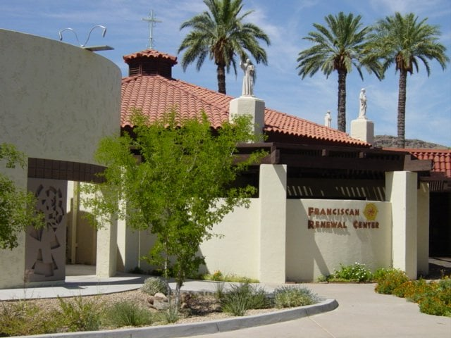

Arizona Summer Christian Ashram
The Franciscan Renewal Center
5802 E Lincoln Drive
Scottsdale, AZ 85253
July 11-13, 2025
www.christianashram.org
azchristianashram.com


Gina Pollard, Evangelist
Gina Pollard leads Cross in the Desert UMC in Phoenix, Arizona. Besides leading her congregation, she is a Certified Grief Recovery Specialist®. A self-described hope junkie, Gina’s calling is to journey with others by helping them validate the whole of who they are in the world and in their lives and to move forward with hope and confidence. Gina earned her Master of Divinity degree from Fuller Theological Seminary. She holds certifications from The Grief Recovery Institute and the Trauma Institute International. She currently serves on the Board of Directors of the Arizona Faith Network.

Tom Albin, Bible Teacher

The Rev. Tom Albin is currently the President of Albin Consulting, LLC, and Director of Development for the United Christian Ashrams, International. He recently retired from his work as the Director of Spiritual Formation and Congregational Life for The Upper Room Ministries, a branch of The United Methodist Discipleship Ministries in Nashville, TN.
Tom is passionate about helping others come to know Jesus and grow into the mature, life-giving, joyfilled people God created us to be. He sees evangelism and discipleship as the natural consequences of our life in Christ and the result of the Holy Spirit’s work in us. He is convinced that every believer has the desire and ability to ‘grow in grace’. Tom and his wife, Maryle, have three married daughters and eight grandchildren.

Registration
Registration Fee: $50.00
Room and Board (6 meals):
$210.00 – Double occupancy per person for the weekend.
$210.00 – Single occupancy
$190.00 – Triple occupancy
$170.00 – Quadruple occupancy
Day rate (includes 6 meals) $120.00 plus registration fee.
Registration deadline is June 1st, 2025. Room and Board must be paid upon arrival at the retreat center.
Deluxe accommodations include two queen beds per room complete with linens. Dinner on Friday, three meals on Saturday, and breakfast and lunch on Sunday are included.
Early registration is advised, as accommodations are limited. Limited handicapped accessible accommodations are available on a first come – first served basis.
Check-in will begin at 2:00 pm on Friday, July 11th, with an orientation at 4:00 pm and the program will begin at 5:00 pm. The retreat will end with lunch on Sunday, July 13th.
Make Checks payable to: Arizona Christian Ashram. Payments can also be made with a credit card, debit card, or PayPal by sending your email address to kateflavell@gmail.com
The registration fee of $_______ is enclosed.
Name(s) ____________________________
___________________________________
Address: ___________________________
___________________________________
Phone number(s): ___________________________________
Email Address(es): __________________________________
__________________________________
Church affiliation: ______________________
Room requirements: ____________________
If you have someone with whom you want to share a room, please indicate that here: ____________________________________
For Questions, please contact Kate Flavell, Ashram Director, at kateflavell@gmail.com
951-515-5176
Mail your registration to:
Cheryle Dunkelberg
14226 N. 37th St. Phoenix, AZ 85032
602-799-6141

To register online go to:
azchristianashram.com Please include your email address for electronic invoicing.

